**JavaScript**

**History**

* It was created in 1995 by Brendan Eich while he was an engineer at Netscape. It was originally going to be named LiveScript but was renamed. Unlike most programming languages, the JavaScript language has no concept of input or output.
* It is designed to run as a scripting language in a host environment, and it is up to the host environment to provide mechanism for communicating with outside world. The most common host environment is the browser

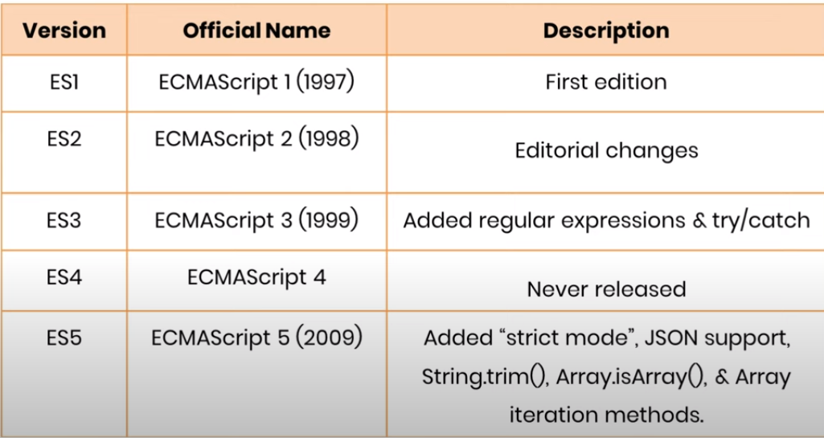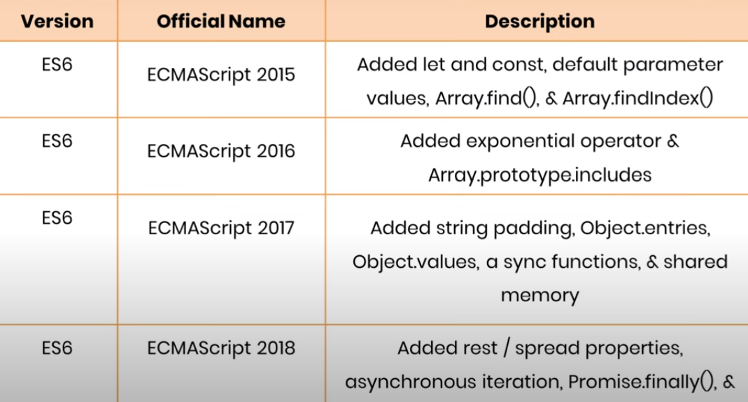

RegExp